FACTORS INFLUENCING THE PERFORMANCE OF SMALL AND MEDIUM-SIZED ENTERPRISES IN NAROK TOWN

NAMNYAK PANGAT
BBM/207/18/19

A RESEACH PROJECT SUBMITTED IN PARTIAL FULFILLMENT OF THE REQUIREMENTS OF BACHELOR DEGREE IN BUSINESS MANAGEMENT
(FINANCE)

DEPARTMENT OF BUSINESS MARIST INTERNATIONAL UNIVERSITY COLLLEGE A Constituent College of the Catholic University of Eastern Africa

NAIROBI, KENYA
JULY, 2021

DECLARATION
I declare that this is my original work and it has never been submitted to any other institution.
SIGNATURE………………………… DATE………………………………
NAMNYAK PANGAT
REG NO: BBM/207/18/19

This project has been submitted to the University for Examination with my approval as the University supervisor.
SIGNATURE…………………………… DATE…………………………….
CPA. FELIX O. RATEMO, BCOM, CCP(K) MSc FINANCE.

This project has been submitted to the University for Examination with my approval as the University Head of Department.

Signed by: ____________________________ Date: _______________________
MADAM LILIAN MULWA

ACKNOWLEDGMENT
Firstly, I sincerely thank Almighty God for good health, wisdom, and energy during the period of this project.
Secondly, I wish to acknowledge my project supervisor, Ms. Felix, for her effort, guidance, and support throughout this period.
I would like to exceptionally express my gratitude to Lilian Mulwa and linda and the staff at large for their continued support that they offered to me and for creating a friendly work environment.
Lastly, I would also like to express my great gratitude to my parents and those who showed their love by supporting me throughout the project period. God bless you all.

DEDICATION
I would like to dedicate this report to my lovely family without forgetting my supervisor

Table of Contents
DECLARATION ii
ACKNOWLEDGMENT iii
DEDICATION iv
ABSTRACT ix
CHAPTER ONE 1
1.0 Introduction 1
1.1. Background of the study 1
1.2. Statement of the problem 2
1.3. General objective 3
1.3.1. Specific objectives 3
1.4. Research Questions 3
1.5. Justification/significance of the study 4
1.6. Scope of the study 4
CHAPTER TWO 6
LITERATURE REVIEW 6
2.0. Introduction 6
2.1 Theoretical frameworks 6
2.1.1 Abraham Maslow Hierarchy of Needs theory 6
2.1.2. Gibrat’s Law of Proportional Effect 6
2.1.3. Social Feminist Theory 6
2.1.4. Sociological Theory 6
2.2. Empirical Review 7
2.2.1. Access to Finance on Performance of SMEs 7
2.2.2. Access to informatics (marketing information) on performance of SM 8
2.2.3 Accessibility of Management Experience on Performance of SMEs 8
2.2.4 Staff Education on Performance of SMEs 9
2.3 Chapter summary 10
CHAPTER THREE 11
3.0 RESEARCH METHODOLOGY 11
3.1 Introduction 11
3.2 Research Design 11
3.3 Target Population 11
3.4 Sample Size Determination and Sampling Technique 12
3.4.1 Sample Size 12
3.4.2 Sampling Technique 13
3.5 Research Instrument 13
3.5.1Questionnaires 13
3.6 Data Collection Procedures 13
3.7 Data Analysis Techniques 14
CHAPTER FOUR 15
4.0 DATA ANALYSIS AND INTERPRETATION 15
4.1 Introduction 15
4.1.1 Response Rate 15
4.2 Background Information 15
4.3 Access to Finance 20
4.4. Marketing information as a Factor affecting SMEs performance 23
4.5. Management as a Factor influencing SMEs Performance 28
4.6. Education and Training as a Factor affecting SMEs Performance 31
CHAPTER FIVE 33
5.0 SUMMARY OF THE FINDINGS, CONCLUSIONS AND RECOMMENDATIONS 33
5.1 Introduction 33
5.2 Summary of the Findings 33
5.2.2 Informatics as a Factor Affecting SMEs Performance 33
5.2.3 Management as a Factor Affecting SMEs Performance 34
5.2.4 Education and Training as a Factor Affecting SMEs Performance 34
5.3 Conclusion 34
5.4 Recommendations 35
5.5. Research Limitations 35
5.6: Further Research 36
REFERENCES 37
APPENDICES 40
APPENDIX I:INTRODUCTORY LETTER 40
APPENDIX II:QUESTIONNAIRE FOR SMES 41
APPENDIX III:BUDGET ESTIMATE 48
APPENDIX III:TIME SCHEDULE 49

ABSTRACT
The SME sector contributes greatly to the economic growth and thus currently recognized and therefore there are high expectations of the SME sector. The purpose of this study was to establish factors influencing the financial performance of small and medium enterprises (SME) in narok town County, Kenya. To achieve this, the study was guided by four objectives which included: to assess the access between finance accessibility and the performance of small and medium sized enterprise in Narok town , to examine the access between staff education and the performance of small and medium sized enterprise in Narok town, to determine the availability between manageialexperience and the performance of small and medium sized enterprise in Narok town, to explore the availability between access to marketing information and the performance of small and medium sized enterprise in Narok town. The study adopted a descriptive research design. The study population was 140 SME Narok town, in Narok County. This study used simple random sampling to sample 30% respondents. The study used a questionnaire in order to collect data. The questionnaire had both open and close ended questions. The completed questionnaires were checked for completeness to ensure consistency. The data was then coded to enable the responses to be grouped into various categories. The findings were presented by use of tables. From the findings the study concluded that that regulatory and administrative environment cause major obstacles for SME Narok town to access financing. The study also concluded that credit and collateral policies did not allow SMEs to use certain assets as collateral since many a pastoralist there a only dependent on the cattle there don’t have proper collateral like title deed others document. The study concluded that access to information had been not given the same attention as other constraints to improve the performance of SME and those SMEs that made good use of structured marketing information services experienced higher business performance.

CHAPTER ONE

1.0 Introduction
This chapter involves the background of the study, statement of the problem, objective of the study, specific objective, research questions, significance/ justification of the study, the scope of the study, limitations of the study, and finally the conceptual framework

1.1. Background of the study
Small and medium-sized Enterprises are independent firms that employ less than a given number of employees, this number varies across countries. That is different countries have different ways of defining SMEs depending on who is defining them and from where are they defining. Garikai (2011) defined SMEs by the number of workers employed, capital employed, and sales turnover.
In the current economy, small and medium-sized enterprises are regarded as powerful engines for economic development in most economies of the world (Islam, Khan, Obaidullah & Alam,2011) Small and medium-sized enterprise are known to have been known to contribute greatly tothe economic growth of both developed as well as developing nations (Muraguri,2010).
SMEs sector may amplify the production capacity which has a significant impact on the promotion of economic and social development (Subhan et al, 2013). Avendano (2013) argued that SMEs provide the majority of employment in developing countries and are keystones in the productive structures of emerging economies. The importance of SMEs is on their ability to provide goods and services, income, and employment to many people (Kauffmann, 2006). According to the South Africa National Credit Regulator (2011), SMEs in South Africa contributes nearly 61% to the country's economy.
The contribution of SMEs to development is generally accredited but SMEs entrepreneurs face many challenges that hinder their long-term survival and development. Levy (2015) viewed finance as a critical element for the financial performance of small and medium-sized enterprises, limit to finance hinder the growth and development of this enterprise's economy. Studies show that there is a positive relationship between SMEs and economic growth in developed nations. However, less research has been done on SMEs in developing countries. Studies in small and medium-sized enterprise's development and performance are essential in countries like Kenya because of the dissimilarities in the process between developed and developing countries (Ihua, 2009).
It is essential to understand the factors affecting small and medium-sized enterprises in developing countries since they differ from the challenges facing SMEs in developed countries, these factors include; access to finance, access to business information, management experience, staff training, and education. In Kenya majority of the SMEs are micro-enterprises with fewer than 10 employees, while 70% of them are one-person, own-account workers. This means that majority of SME entrepreneurs are operating at the bottom of the economy, among the 53 percent of Kenyans living below the poverty line of USD 1 per day, most of them engage in subsistence and economically uncompetitive activities both in urban and rural areas (Kihonge, 2014).

1.2. Statement of the problem
Small and medium-sized enterprises play a great deal in individual and national development. A recent national Economy survey report by the central bank of Kenya (CBK) indicates that SMEs constitute 98% of all businesses in Kenya, create 30% of jobs annually. Kenyans 2017 overall GDP growth is projected at 6.4% with SMEs contributing 3%.
Zindiye (2008) did an empirical investigation into the factors affecting the performance of small and medium enterprises in the manufacturing sector of Harare, Zimbabwe. The findings indicated that high rate of inflation and other economic factors such as foreign currency shortage, interest rate and exchange rate negatively affected the performance SMEs.
According to a report by Delloite Kenya Economic outlook 2016, SMEs are hindered by inadequate capital, limited market access, inadequate knowledge &skills, rapid changes in technology, corruption, and unfavorable government policies. A study by Nabintu (2013) investigating the factors affecting the performance of SMEs traders at city park hawkers market in Nairobi county, Kenya, showed that access to finance, business information affected the performance of businesses to a great extend; technology affected the business to a great extent by facilitating communication with both the supplier and customers, ensuring quick of goods and easing marketing of the products.
Most of the studies have focused on the factors affecting the performance of SMEs in big cities, there is a scarcity of literature focusing on SMEs in fast-growing towns. This study will therefore focus on the factors influencing the performance of SMEs in Narok town.
The study seeks to investigate the factors that influence the performance of small businesses to understand the dynamics of SMEs not only for the development of support programs and growth strategies of SMEs but also for the growth of the economy as a whole. Such information is crucial in the evolution of appropriate policies for promoting SME development and increasing the sector's impact on poverty reduction and overall development.

1.3. General objective
To investigate the factors influencing the performance of small and medium-sized enterprises in Narok town.

1.3.1. Specific objectives
1. To assess the access between finance accessibility and the performance of small and medium-sized enterprises in Narok town.
2. To explore the availability between access to marketing information and the performance of small and medium-sized enterprises in Narok town.
3. To determine the availability between managerial experience and the performance of small and medium-sized enterprises in Narok town.
4. To examine the access between staff education, and the performance of small and medium-sized enterprises in Narok town.

1.4. Research Questions
The study was guided by the following research questions:
1 .How does finance accessibility affect the performance of small and medium-sized enterprises in Narok town?
2. How does access to marketing information affect the performance of small and medium-sized enterprises in Narok town?
3. How does Management experience affect the performance of small and medium-sized enterprises in Narok town?
4. How does staff education affect the performance of small and medium-sized enterprises in Narok town?

1.5. Justification/significance of the study
The county government of Narok will benefit from the information provided by first of all becoming aware of the challenges experienced by the SMEs and call for a mechanism to address and seek solutions. The government’s strategy to empower entrepreneurs in the vision 2030 will be supported by the study and it will thus enable them to determine shortfalls and gaps which need to be addressed and decisions made by management to make solid decisions about the required actions in addressing the financing of SMEs. Similarly, it will be beneficial to the national government of Kenya for policy formulation that will create a suitable environment for the small and medium-sized enterprises to increase business growth and the economic standard in the country.
Besides, the study will be important to the Kenya Revenue Authority for taxation and also reaching out to this group of income earners who may not know that they should pay tax as per the laws of Kenya. Last but very important, the study is of much significance to research institutions, students, and other researchers who would get the findings useful in their investigation in the area of study.

1.6. Scope of the study
This seek to focused on small and medium-sized enterprises in Narok town, over one month. The primary focus was limited to the assessment on factors influencing the performance of small and medium-sized business enterprises (SMEs) in Narok with the majority of SMEs initiated everyday by residents and visiting citizens, many of whom have opted to settle and live here in search of a livelihood.

1.7. conceptual framework
Figure 2.4: The relationship of the variables
Access to finance
- source of capital
- Accessibility to loans

Performance of SMEs in Narok town
- Increase in profit
- Additional stock
- Decrease in debts level

Access to business information
- Knowledge level among entrepreneurs

Managerial experience
- Time taken to perform a particular job

Staff education and training
- Training the workforce on job performance.

Dependent variable
Independent variables

CHAPTER TWO

LITERATURE REVIEW

2.0. Introduction
This chapter reviews existing literature on the subject of this study it outlines the theoretical and ,empirical review, and the summary.

2.1 Theoretical frameworks

2.1.1 Abraham Maslow Hierarchy of Needs theory
The entrepreneur’s performance is personal and can be attributed to the Hierarchy of Needs theory which was coined by psychologist Abraham Maslow. The theory states that individual basic needs must be met before they become motivated to achieve higher level needs. The hierarchy is made up of five levels namely physiological, safety, love, esteem and self-actualization. On self-actualization, the theory holds that the individual will desire to achieve everything possible and become the most they can be. This relates to personality factor and its influence on business performance.

2.1.2. Gibrat’s Law of Proportional Effect
Gibrat’s law or the law of proportionate Effect, state that factors that influence a firm growth such as increase in demand, management talent, innovation, organizational structure and luck, are distributed across firms in a manner which cannot be predicted from information about the firm’s current size or its previous growth performance(Goddard et al,2004).

2.1.3. Social Feminist Theory
From a gender perspective, the social feminist theory, which emanates from the social learning theory and psychoanalysis, holds that differences between men and women exist from their earliest moments in life and result in fundamentally different ways of viewing the world. These differences are seen in the way women and men construct and interpret reality and how these influence the formation of their values and intention. Men and women are inherently different because of difference in their socialization, training and experiences encountered prior to entry into particular work positions and business. The theory relates to the gender attribute of social background and its impact on business performance.

2.1.4. Sociological Theory
According to sociological theory, it holds that social culture is the major driver of entrepreneurship. Social culture includes role expectations in the society which is a function of religious beliefs, norms, and taboos and customs. Therefore, the entrepreneur plays a very good role in conformity with the expectations of the society. Weber (1920) held that religious beliefs are the major drivers of entrepreneurial culture. Weber’s main focus was on capitalism where he highlighted on economic freedom and private enterprise as boosters of enterprise performance. For an entrepreneurship to be successful there must be the right combination of discipline and freedom of adventure.

2.2. Empirical Review

2.2.1. Access to Finance on Performance of SMEs
Lack of access to finance is almost universally indicated as key problem for SMES. Credit constraints operates in a variety of ways in Kenya where undeveloped capital forces entrepreneurs to rely on safe financing or borrowing from friends which is no enough to enable SMES to undertake their business optimally.
A study by Kinyua (2014) investigating on the role of finance on the performance of small and medium enterprises in Jua kali sector in Nakuru Kenya, employing a survey research design revealed that access to finance has the potential to affect positively the performance of SMEs.
Macharia (2012) employing stratified technique studied the effect of access to finance on micro and small enterprises investment growth in Ongata Rongai Township. The study found that in financing of micro and small businesses, families and friends play a big role in helping the business owners boost the operations with an average of 40% coming from them, and average of 24% come from financial institution while an average of 30% of finance were from business saving. The study also showed that the main hind race of SMES in getting access to formal financial services results from lack of credit service awareness, lack of collateral, bank vetting procedures, requirement of guarantors, cost of loans and the employment and security issue are some of the obstacle hindering utilization of the available credit facilities.
Infant businesses need support in their early years when their motivation is high and innovation is low and collateral requirement at financial institution should be made a bit flexible and repayment period should be increased to at least a years because SMES only manage to access a small amount of loan due to a small repayment period, Some SMES sales turnover decrease from previous years due to operating cost brought about by interest rates on the loan advanced. Kenyan Banks should address issues like lending procedure, collateral requirement and repayment period to ensure customer satisfaction (Mwania, 2011).
Okapara (2011) investigating the role of financial support on the growth and survival of small businesses in Nigeria, employing the survey method found out that lack of financial support is the most constraint hindering the growth and survival of small business in the country.

2.2.2. Access to informatics (marketing information) on performance of SM
Access to marketing information has been recognized as one area that needs attention from governments and business services providers if the SMEs sector has to achieve sustainable levels of growth and development. Many firms in Kenya operate in a poor information environment due to lack of sufficient financial information and lack of good technological infrastructures. Access to information has not been given the same attention as other factors affecting growth and development of SMEs such as access to finance, markets and training (Kimunyi, 2015).
Over the years, accessing marketing information has been greatly enhanced with the emergence of various information and communication technologies. In developed countries, because of well- developed Information and Communication Technologies (ICTs) infrastructure and easy access to computer hardware and software, SMEs enjoy easy access to marketing information services, which has affected the business to a great extent by facilitating communication between customers and suppliers, by easing the transportation of goods and easing marketing of our product (Nabintu,2013)
Tan, Choo, Chang & Moorthy (2012) investigated the role of market information to performance of SMES in manufacturing sector in Malaysia, the findings showed that there is a significant
Positive relationship between the use of market information as well as application of IT and performance of SMEs. In short it shows that the use of market information can influence the performance of SMES at the highest level.

2.2.3 Accessibility of Management Experience on Performance of SMEs
Many SMEs bosses lack managerial training and experience which is needed to run their business. Managers of small businesses develop their own approach to management, through a process of trial and error. This is not an effective way of management since it will focus on day today activities of the organization and fail to focus on long term goals. Despite of this attitude being the key strength at the initial stage of the enterprise because it provides the creativity needed, it may bring problems when complex decisions have to be made. A consequence of poor managerial ability, SMEs owners are poorly prepared to face changes in the business environment and to plan for appropriate technological changes.
Entrepreneurs require managerial skills capable of positing business effectively within a complex business environment (Muturi, 2016). Training of management is vital to the success of the firm. Research indicated that the association should organize seminars, workshops for the owners, managers as well as the staff s of these areas such as customer care, basic mechanical operators, with a view of enhancing their profitability.
Mugo(2012) investigating factors affecting women entrepreneurs performance in Central Business District (CBD) in the city of Nairobi, found out that lack of entrepreneur training and education, lack of management skill are the major impediments affecting the performance of women entrepreneurs, the study advocated for women education through seminar to help them keep proper records which show proper business operation and help them access the business margins and mark ups to weigh the rate of business return on their own.
Another study by Kinyua (2014) revealed that management skill had positive and significant impact on performance of SMES in Jua kali sector Nakuru town Kenya. The study recommended on acquiring appropriate management skill such as financial, marketing and entrepreneur skill in order to increase SMES performance.

2.2.4 Staff Education on Performance of SMEs
Mohamud (2014) investigating the effect of training on employee’s performance in public sector organization in Kenya, Case study of NHIF Machakos county. The study found out that training had an impact on organizational activities s despite the challenges from the management which includes poor motivation, lack of compensation policy, poor working condition etc. The study recommended that management should offer training and workshop opportunities for staff in order to keep them updated and improve their knowledge and skills. Poorly performing staff should also be appraised and reasons for their dismissal performance determined instead of condemning them.
Abdullah &Fatihah (2015) evaluating on determinants of SMEs performance in Malaysia using structured equation modeling partial least squares method, found out that the human resource management is significant on the performance of SMEs. The study suggests that for future planning SMEs owner or managers can focus on this aspect so as to develop more on their business performance.
The increasing interest in training and development is due to the assumption that employees and the way they are managed are critical to the success of a firm. (Omolo,2015) investigated the influence of training and development on the performance of SMEs in Kisumu county, using cross sectional survey research design, the study revealed that the performance of SMEs is associated with the status of training and development and that the better the status of training and development in an SMEs, the higher the performance of SMEs.

2.3 Chapter summary
The study is on the factors affecting influencing performance of SMEs in Narok town, Kenya. This factor include accessibility to finance, business information, managerial skills and education and training of the workforce. Some of the studies quoted includes, Mwania (2011) on the effect of Biasharaboresha Ltd (BBL) on performance of SMEs owned by Kenyan commercial Bank Ruiru branch, Kinyua (2014) on the factors affecting performance of SMEs in Nakuru town. Mugo (2012) on the factors affecting performance of women entrepreneurs in Central business district of Nairobi. The scholars agreed that all the mentioned factors have an impact on financial performance of small and medium enterprises.
The scholars have addressed the factors affecting SMEs in cities and urban areas, but they have not addresses the factors affecting SMEs in fast growing towns yet they are the one facing a lot of challenges. This study will focus on factors influencing performance of small and medium enterprises in Narok town.

CHAPTER THREE

3.0 RESEARCH METHODOLOGY

3.1 Introduction
This chapter presents the research methodology adopted in conducting the study in order to achieve the study’s objective which was to find out factors influencing performance of SMEs in Narok town, the chapter was thus structured into research design, target population and sample size and sampling technique, research instrument, data collection procedures as well as data processing and analysis technique.

3.2 Research Design
Research design refers to the master plan that will be used in the study in order to answer the research questions (Nachmias&Nachmias, 1996). The study adopted the descriptive design since the study seeks to solve the questions of why, how, and when of the problem covered in the study. The basic advantages of the descriptive design are the ability to use various forms of data as well as human experience. The design allows the researcher to employ various aspects in the study contrary to the other forms of research.
Descriptive research entails field survey in which the researcher visits the population of interest to ask questions concerning the area of study. Mugenda (2003) states that descriptive research design is a systematic, empirical inquiring into which the researcher has no direct control of independent variable as their manifestation has already occurred or because they inherently cannot be influenced. The inferences about the relationship between variables are derived from concomitant variable.
The research design was a survey conducted on SMEs within Narok town. According to Owens (2002) Research design is advantageous in that it is very unique, the information collected may not be available when other sources of research are used. The research has unbiased representation of population of the interest and it enables standardization of measurement since similar information is gathered from every respondent.

3.3 Target Population
Target population is a set of people, services, element, events and group of things or households that are being investigated (Ngechu, 2004).
The target population of this study consisted of all SMEs operating in Narok town in Narok County. From the records of the county government of Narok there are approximately 140 registered business in Narok town. The business in operation are mainly, Hotels, Curio shops, Retailers and wholesalers. This is shown in table 3.3
Table 3.3 Target population
Business | population
Hotels | 14
Curio shops | 5
Retailers | 100
Wholesaler | 21
TOTAL | 140

3.4 Sample Size Determination and Sampling Technique
The section discusses the sampling technique and how the sample size is arrived at. The sampling design refers to the sampling method used to arrive at the sample size.

3.4.1 Sample Size
According to Mugenda and Mugenda (2003) a sample of 10-30% is good enough if well-chosen and when the study population is less than10, 000. According to Narok county records there are approximately 140 SMEs operating in Narok town. The SMEs that formed the sample were calculated using the sample formula (Mugenda & Mugenda 2003) as follows;30%X 140=42
Table 3.4 Sample Size of representation
Location | Population | Percentage | Sample Size
Hotels | 14 | 30% | 4
Curio shop | 5 | 30% | 2
Retailers | 100 | 30% | 30
Wholesalers | 21 | 30% | 6
TOTAL | 140 |  | 42

3.4.2 Sampling Technique
A sampling technique is a method used to select the sample elements from a population to represent the population as a whole. The study employed the stratified random sampling technique where by 30% of the population in each sampling frame was selected to participate in the study. According to (Saunders, et.al. 2007) stratified random sampling technique is a modification of random sampling where by the population is divided into two or more relevant and significant strata based on one or more attributes.
Stratified sampling is accurate, easily accessible, and divisible into strata and it enhances better comparison. The advantage of stratified sampling is its ability to ensure inclusion of subgroup, which could otherwise be omitted entirely by other sampling methods because of their small number in the population (Kothari, 2004).

3.5 Research Instrument
The study used both open and closed ended questionnaire to gather research data.

3.5.1Questionnaires
According to Gay (1996) descriptive data are usually collected using questionnaires. The data collected using questionnaires is primary data. Cooper and Schindler (2006) defines primary data as original search where data being collected is designed specifically to answer the research questions. This study used both open and closed ended type of questionnaire. This questionnaire were shared by the respondents through hand delivery. The researcher ensured that confidentiality was maintained and the respondents were not expected to reveal their identity while filling in the questionnaires. The questionnaire is divided into the main areas of investigation apart from the first part which captures the Background information. Other sections include; financial related matters, staff education and training, marketing information and managerial factors.

3.6 Data Collection Procedures
The researcher seeked authorization from the respondents by first issuing the introductory letter to them. Then, the researcher administered the questionnaires to the relevant respondents in an effort to achieve necessary information. The researcher ensured ethical consideration were observed during the data collection process. Sell-administered questionnaire were left to participant to respond to the questions by themselves and at their own pace, they ease the respondent’s burden by giving them the time to think through their responses. Data from the respondents was analyzed and result interpreted for correctness of the research instrument.

3.7 Data Analysis Techniques
Data analysis is the process of bringing order, structure and meaning to the mass of information collected (Mugenda & Mugenda, 2003). The data entry process started as soon as questionnaires came from the field. Data obtained from the field is in raw form and is difficult to interpret unless it is cleaned, coded and analyzed. The qualitative analysis involved examining, categorizing, tabulating, and recombining evidences to address the research questions. The qualitative data was grouped into meaningful patterns that were observed to help in the summarizing and organization of the data. Data was analyzed using Ms. Excel, and presented using pie charts, tabulation and bar charts to enable ease of use, understanding and appreciation. The qualitative data will be analyzed descriptively.

CHAPTER FOUR

4.0 DATA ANALYSIS AND INTERPRETATION

4.1 Introduction
This chapter presents analysis and findings of the study as set out in the research methodology. The study findings are presented on to establish the factors influencing the performance of small and medium-sized enterprises with specific reference to the SMEs at Narok town in Narok County. The data was gathered exclusively from the questionnaire as the research instrument. The Questionnaire was designed in line with the objectives of the study.

4.1.1 Response Rate
The study targeted 42 respondents in collecting data with regard to the factors influencing the performance of small and medium-sized enterprises with specific reference to the SMES at Narok town in Narok County. From the study, 36 out of the 42 sample respondents filled-in and returned. The questionnaires making a response rate of 85.7%. This response rate was arrived at after personal calls and visits to remind the respondent to fill-in and return the questionnaires.

4.2 Background Information
Table 4.1 Form of business ownership
Form of business | Number | Percentage
Sole proprietor | 30 | 83%
Partnership | 6 | 17%
Total | 36 | 100%

The study found out that 83% of the SMEs in Narok town are owned and operated by individuals, while 17% of the businesses are owned by more than one person.

Figure 4.1: Duration of time the Respondent's business has been in existence
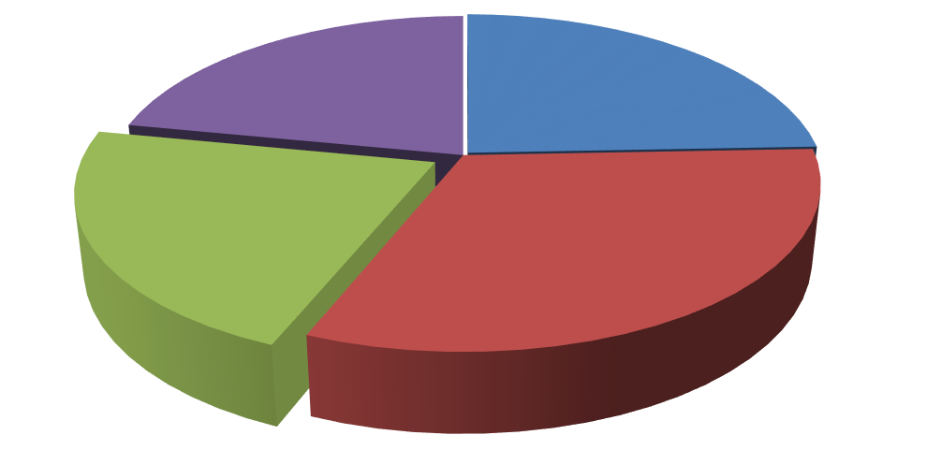

24
%
32
%
22
%
22
%
Less than 1 yr.
1-3
Yrs.
4-5
Yrs.
More than 5 yrs.
The study sought to find out the duration of time has been in existence. From figure 4.1, 32% of the respondents indicated that their businesses had been in existence for 1-3 years, 22% of the respondents indicated that their businesses had been in existence for more than 5 years similar to those who had their business being in existence for 4-5 years. On the other hand, 24% of the respondents indicated that their business had been in operation for less than 1 year.

Table 4.2: Number of permanent employees
Permanent | Respondents | Cumulative Percentage
1-10 | 12 | 86%
11-50 | 2 | 14%
50 and Above | 0 | 0%
TOTAL | 14 | 100%

The study sought to find out the number of permanent employees in the Respondent's Business. From the findings, 86% of the respondents indicated that they had between 1 and 10 permanent employees in their businesses, 14% of the respondents indicated that they had between 11 and 50 permanent employees in their businesses, none of the respondents indicated to have had 50 and above permanent employees in their businesses.
Table 4.3: Number of casual employees
Casual | Frequency | Cumulative Percentage
1-10 | 16 | 76%
11-50 | 5 | 24%
50 and Above | 0 | 0%
total | 21 | 100%

The study sought to find out the number of casual employees in the Respondent's Businesses. As shown by table 4.3, 76% of the respondents indicated that they had 10 and below casual employees in their businesses, 24% of the respondents indicated that they had between 11 and 50 casual employees in their businesses; whereas none of the respondents indicated that they had between above 50 casual employees in their businesses.

Figure 4.2: Whether respondent's business has grown since they were started
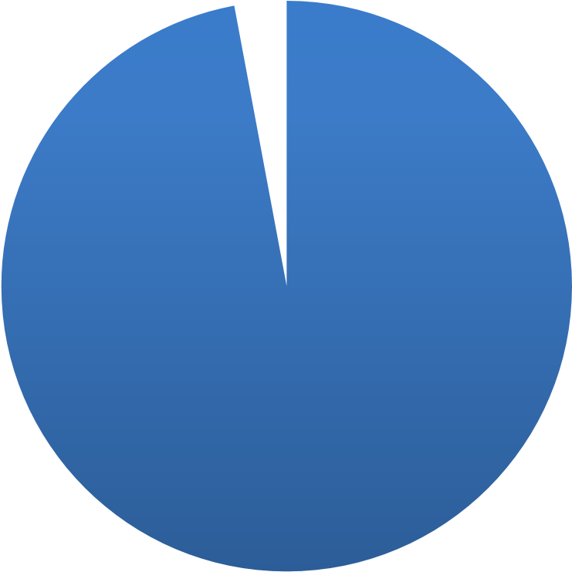

97
%
3
%
Yes
No
The study sought to find out whether respondent's business has grown since they were started. From the findings, 97% of the respondents indicated that their businesses had grown since they were started whereas only 3% of the respondents indicated that their businesses had not grown since they were started.
Figure 4.3: Respondent’s indicators of growth in the Respondent's business

0
10
20
30
40
50
60
Decrease in debts level
Business has expanded
Profits have increased
Percentage
The study sought to find out the indicators of growth in the Respondent's businesses. From the findings, 52% of the respondents showed that the indicator for their businesses growth was an increase in profits, 43% of the respondents indicated that the indicator for their businesses growth was business expansion. Only 5% of the respondents indicated that the indicator for their businesses growth was decrease in debts level.

Figure 4.4: Respondent’s estimates of annual returns.
0
10
20
30
40
50
60
1-100,000
100,001-
250,000
250,001-
500,000
500,001
and
above
Percentage
The study sought to find out the estimated annual returns for the SMEs. From the findings, majority of them (50%) indicated to have had between 100,000 and 250, 000. 35% indicated to have earned between 250,000 and 500,000, 11% indicated to have earned between 1 and 100,000. Similarly, 4% showed to have above 500,000.

4.3 Access to Finance
Figure 4.5: Whether Respondents have ever used loans
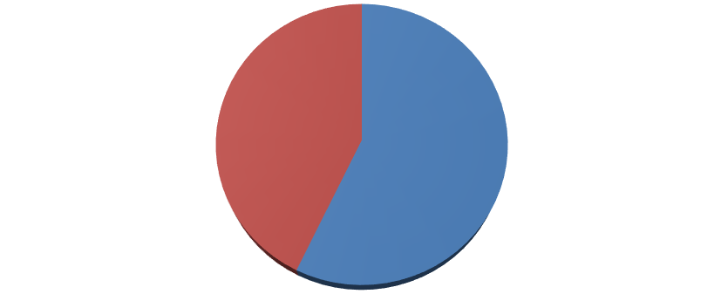

57
%
43
%
Yes
No
The research has indicated that 57% of the respondents have ever used loans while 43% have not used before. This shows that a good number of SMEs have been financed through loans; hence the loans form the major financing of SMEs in Narok town.

Figure 4.6: Institutions where respondents accessed loans

0
10
20
30
40
50
Commercial
Banks
Micro-Finance
Inst.
Familyandrrerelatr
Friend
SACCOS
Percentage
The study sought to find out where respondents applied their loans. From the findings, out of the 57% who ever applied for loans, 46% of the respondents indicated that they obtained the loans for their businesses from commercial banks. On the other hand, 30% of the respondents indicated that they borrowed loans for their businesses from Micro-Finance institutions whereas, 18% of the respondents indicated that they acquired loans from SACCOS. Only, 6% of the respondents showed that they accessed loan from family and friends.
Figure 4.7: What prevents Respondents from borrowing money from banks?

0
10
20
30
40
50
60
You don’tlike
Loans
High interest
Rates
Lack of collateral
Bank Loans are
meant for large
Organizations
Fear of losing
Property
Percentage
of
Respondents
The study sought to find out what prevented respondents from borrowing money from banks. From the findings, 52% of the respondents indicated that high interest rates prevented them from borrowing money from banks, 20% of the respondents indicated that lack of collateral to use as security prevented them from borrowing money from banks, 16% of the respondents indicated that they did not like to borrow credit from commercial banks, 6% of the respondents indicated that they thought that loans were for big companies and therefore did not see the need to borrow money from banks while the rest of the respondents, (6%) indicated that fear of losing property prevented them from borrowing money from banks.
Figure 4.8: Highest amounts that Respondent's enterprises borrowed successfully from a bank
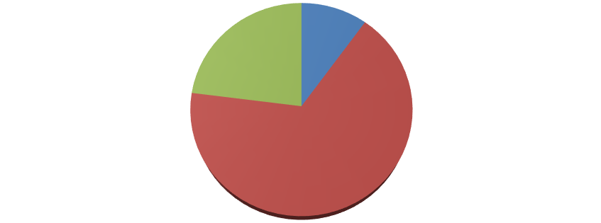

10
%
67
%
23
%
1-50,000
50,001-300,000
300,001
and above
The study sought to find out the highest amounts that respondent's enterprises borrowed successfully from a bank. From the findings, 67% of the respondents indicated that the highest amounts they had borrowed successfully from a bank was between Ksh50,001 to Kshs. 300,000, 23% of the respondents indicated that the highest amounts they had borrowed successfully from a bank above Ksh. 300,000. Only 10% of the respondents indicated that the highest amounts they had borrowed successfully from a bank was Kshs 50,000 and below.

Figure 4.9: What should be done to improve the rate at which the SMEs access finance.
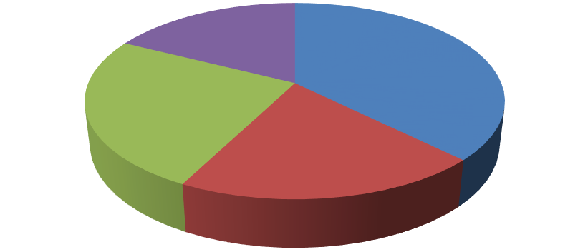

37
%
20
%
25
%
18
%
Reduce interest
Rates
Increase the number
of loan providers
Reduce lengthy
Procedures
Increase repayment
Period
The study sought to find out what should be done to improve the rate at which the SMEs access finance .From the findings,37% of the respondents indicated that interest rates should be reduced,25% showed that the lengthy loan acquisition procedures should be reduced ,whereas 20% of the respondents indicated that the number of loan providers should be increased. Only 18% of the respondents indicated that the repayment period of the borrowed loans should be extended.

4.4. Marketing information as a Factor affecting SMEs performance
Figure 4.10: Respondents’ feedback on whether they market their products

77771`1
0
10
20
30
40
50
60
70
80
Agree
Disagree
Key: Percentage of respondents
The study sought to find out whether the respondents market their products. From the findings, 71% of the respondents do market their products at all while 29% of the respondents indicated that they do not market their products.
Figure 4. 11: How Respondents market their products

0
10
20
30
40
50
60
70
Word of mouth
Dropping of leaf lets
Print media
Television
Key: Percentage of respondents
The study wanted to find out how respondents market their products. From the findings, 59% of the respondents who market their products indicated that they market their products through word of mouth, 25% of the respondents indicated that they market their products through dropping of leaflets, 8% of the respondents indicated that they market their products through print media, while 8% of the respondents indicated that they market their products through television.
Figure 4.12: Respondent's opinion as to whether marketing is a barrier to enterprise Performance

0
10
20
30
40
50
60
70
80
90
Agree
Disagree
Key: Percentage of respondents
The study sought to find out the respondent's opinion as to whether marketing is a barrier to enterprise performance. From the findings, 79% of the respondents agreed that marketing is a barrier to enterprise performance, while only 21% of the respondents disagreed that marketing is a barrier to enterprise performance.

Figure 4. 13: Respondent's level of agreement on whether availability of Information and marketing tools is vital for growth of SMEs.

0
10
20
30
40
50
60
70
80%%
Agree
Disagree
Key; percentage of respondents
The study sought to find out the respondent's level of agreement as to whether availability of Information and marketing tools is vital for growth of SMEs. From the findings, 67% of the respondents agreed that availability of Information and marketing tools is vital for growth of SMEs, while only 33% of the respondents disagreed that availability of Information and marketing tools is vital for growth of SMEs.
Figure 4. 14: Respondent's level of agreement on whether Knowledge of Information and Communication Technology (ICT), is important for the good performance of SMEs.
Key; Percentage of respondents

0
10
20
30
40
50
60
Agree
Disagree
The study sought to find out the respondent's level of agreement on whether Knowledge of Information and Communication Technology (I C T), is important for the good performance of SMEs. From the findings, 57% of the respondents agreed that Knowledge of Information and Communication Technology (I C T) is important for the good performance of SMEs, while only 43% of the respondents disagreed that Knowledge of Information and Communication Technology (l C T), is important for the good performance of SMEs.
Table 4.4: Whether respondents have used various ICT terms in the course of their business transactions.
ICT | Number of users | percentage%
Mobile Banking | 26 | 72%
E- Banking | 5 | 14%
E- Commerce | 3 | 8%
E-Learning | 2 | 6%
TOTAL | 36 | 100%

The study sought to find out whether respondents had used or come across various lCT terms in the course of their business transactions. From the findings, 72% of the respondents had come across and used mobile banking in the course of their business transactions, 14% of the respondents indicated that had come across the word E-banking in the course of their business transactions, 8% of the respondents indicated that had come across the word E-commerce in the course of their business transactions, 6% of the respondents indicated that had come across the words E-learning, while none of the respondents indicated that had come across the word E-shopping in the course of their business transactions.

4.5. Management as a Factor influencing SMEs Performance
Figure 4.15: Level of Education of the enterprise owner

10
%
5767
%
33
%
University
Secondary School
College

The study sought to find out the level of education of the business owner. From the findings, 57% of the respondents indicated that they have attained secondary school level, 33% have attained colleges and 10% of the respondents have university qualification.
Figure 4.16: Whether business plan can lead to improvement of management style

0
10
20
30
40
50
60
Yes
No
Respondent percentage
The study sought to find out whether developing a business plan can improve the management style of SMEs. From the findings, 54% of the respondents agreed that developing a business plan improves management style while the remaining 46% disagreed with the idea of a business plan.
Figure 4.17: Records maintained by the enterprise.

0
10
20
30
40
50
60
Employee’s
Record

Accounting
Record
Sales record
Production
record

Cost record

Percentage
Of
Respondents
The study sought to find out the records maintained by respondent's enterprises. From the findings, 34% of the respondents kept employee records, 24% of the respondents kept accounting records, 22% of the respondents kept sales records, 12% of the respondents kept production records, while only 8% of the respondents kept costs records.

Figure 4.18: Practical experience that management team have run the enterprise

36
%
22
%
26
%
16
%
3 Years

Over 3 years

2 Years
1 year

The study sought to find out the number of years of experience that management teams in respondents’ enterprises must have in running the enterprise. From the findings,36% of the respondents indicated that management teams in their enterprises must have three (3) years' experience in running the enterprise, 26% of the respondents indicated that management teams in their enterprises must have two (2) years' experience in running the enterprise, 22% of the respondents indicated that management teams in their enterprises must have over five (3) years' experience in running the enterprise, while only 16% of the respondents indicated that management teams in their enterprises must have one(1) years' experience in running the

4.6. Education and Training as a Factor affecting SMEs Performance
Figure 4. 19: How often respondent's enterprises send staff for refresher courses or training programs
Key: Respondent percentage
0
10
20
30
40
50
60
Never send
Rarely send
Often send
The study wanted to find out how often respondent's enterprises sent staff for refresher courses or training programs. From the findings, 57% of them indicated that their enterprises never sends staff for refresher courses or training programs, 36% of the respondents indicated that their enterprises rarely send staff for refresher courses or training programs, 7% of the respondents indicated that their enterprises often send staff for refresher courses or training programs while.

Figure 4.20: Whether lack of education and training affects the performance of respondents’ enterprises

0
10
20
30
40
50
60
70
80
Agree
Disagree
Key: percentage of respondents
The study sought to find out whether lack of education and training affects the performance of respondent's enterprises. From the findings, 76% of the respondents agreed that lack of education and training programs is a challenge affecting performance of SMEs, while 24% believed that lack of education and training is not a challenge affecting performance of SMEs.

CHAPTER FIVE

5.0 SUMMARY OF THE FINDINGS, CONCLUSIONS AND RECOMMENDATIONS

5.1 Introduction
The chapter provides the summary of the findings from chapter four, and it also gives the conclusions and recommendations of the study based on the objectives of the study. The objectives of this study were to investigate into the factors influencing performance of small and medium enterprises with specific reference to the SMES at Narok town (Narok County).

5.2 Summary of the Findings
The study purposed to investigate into the factors influencing performance of small and medium enterprises with specific reference to the SMES at Narok town (Narok County)
5.2.1 Access to Finance as a Factor Affecting SMEs Performance
It was found out that respondents financed their businesses from commercial banks, micro finance institutions, SACCOS and loans from family and relatives. The major sources of the business finance were 46% from commercial banks, 30% from Micro-Finance institutions, 18% from SACCOS and 6% from family and friends.
From the findings 52% of the respondent indicated that high interest rate prevented them from accessing the loan, 20% indicated that lack of collateral security prevented them from borrowing money from banks, 16% indicated that they don’t like borrowing from commercial banks, 6% indicated that loans are meant for big companies so they didn’t see any need to borrow money from banks and 6% indicated that fear of losing properties prevented them from borrowing. The study found out that most of the respondents advice for interest rate reduction so as to increase SMEs access to finance as indicated by 37%

5.2.2 Informatics as a Factor Affecting SMEs Performance
The study found out that lack of access to marketing information is a barrier to enterprise performance, it also found out 59% of respondents market their products through word of mouth, 25% market their products through dropping of leaflets, 8% through print media, and 8% through television; Further, that respondents had come across various ICT terms like E-banking, Mobile banking, E-learning, and Ecommerce in the course of their business transactions.

5.2.3 Management as a Factor Affecting SMEs Performance
The study also found out that developing a business plan leads to improvement in management style as indicated by 54% of the respondent. Besides, the study found out that the enterprises kept employee records, accounting records, sales records, production records, and costs record. From the findings, majority of the respondent indicated that the management team should have at least three years of experience as indicated by 36%.

5.2.4 Education and Training as a Factor Affecting SMEs Performance
The study found out that 57% of the enterprises never send staff for refresher courses or training programs, 36% of the enterprises rarely send staff for training and refresher courses and 7% of the enterprises often send staff for training and refresher courses. From the findings, 76% of the respondents agreed that lack of education and training, affect the performance of SMEs

5.3 Conclusion
The study concludes that most SMEs in Narok town finance their businesses from bank loans, Micro- finance institutions, SACCOs and loans from family and relatives; that high interest rates, lack of collateral, dislike to borrow from banks, and fear of losing property prevented some of the SMEs from borrowing money from the banks; that reduced interest rate, increased repayment period, increased number of loans providers and reduced lengthy procedures could improve SMEs access to finance. Therefore, Financing is a setback to the growth of their businesses.
Further, the study concludes that lack of access to marketing information is a barrier to enterprise performance; that respondents market their products through media print, through dropping of leaflets, through word of mouth, and through television, Further, that respondents had come across various ICT terms like E-banking, E-shopping, E-learning, mobile banking and Ecommerce in the course of their business transactions.
The study also concludes, developing a business plan leads to improvement in respondent's management style. The study also concludes that the enterprises kept employee records, accounting records, sales records, production records, and costs records which are important in determining the performance of the business. Lastly, the management teams in their enterprises must have at least three (3) years' experience in running the enterprise.
The study concludes that enterprises rarely send staff for refresher courses or training programs, the respondents are in the agreement that training staff will lead to improvement in the enterprises performance. Besides, the use of modern technology without good training programs does not lead to performance improvement in their enterprises and SMEs.

5.4 Recommendations
Since most SMEs in Narok town finance their businesses from bank loans, loans from Micro- finance institutions, SACCOS and loans from family and relatives, the commercial banks should avail more credit facilities to the SMEs. SMEs owners should organize themselves in SACCOs to save for capital to finance and boost their businesses. The Central Bank should liaise with Commercial banks to lower interest rates to encourage more SMEs to borrow money from the banks. Further, the banks should review their security to pledge criteria so as to encourage more SMEs to borrow money from the banks.
Since marketing is a barrier to enterprise performance SMEs should market their products through media print, through dropping of leaflets, through word of mouth, and through television, and the marketing departments of the enterprise should be more aggressive so as to reach more customers which will lead to increase in enterprise sales and profit. The fact that Information and marketing tools is vital for growth of SMEs, the enterprises should assign a substantial amount of their budgets to develop information and marketing structures for their businesses.
Organization should also have a business plan for it is critical for the success of the business, keep employee records, accounting records, sales records, production records, and costs records; that respondents should have good internal control systems in their businesses; and ensure that management teams in their enterprises have at least three (3) years' experience in running the enterprise to improve their enterprises performance.
Enterprises should send staff for refresher courses or training programs to develop skill for their staff, This should be through in-house training by external trainers and own trainers, in-house brainstorming, sending staff for training at Kenya Industrial Training to develop their skill and make them trained professionals hence improvement in the enterprises performance.

5.5. Research Limitations
The study mainly depended on the data provided by the respondents. Therefore, the accuracy of the data provided depended on the information provided. The researcher handled the problem by making follow-up calls to clarify any issues that were not clear. In addition, business information is usually confidential thus some of the respondents approached were reluctant in giving information due to fear of being victimized.
The researchers handled the problem by carrying an introduction letter, so as to assure the respondents that the information will be treated as confidential and will be used for academic purposes only. The researcher exercised utmost patience and make extra effort in reminding respondents and making constant follow-ups so as to acquire sufficient data from respondents.

5.6: Further Research
This study has investigated factors influencing the performance of small and medium enterprises with specific reference to the SMES at Narok town (Narok county).To this end therefore a further study should be carried on SMES at other counties in Kenya to see whether the same results also hold by testing the variables in this study on SMEs.
Moreover, a study should be carried out to investigate the impact of government policies on the performance of SMEs in Narok town.

REFERENCES
Avendano, R, Boehm N, &Calza E. (2013). Why scarce small and medium enterprise financing
hinder Growth in Latin America. Journal of the Role for public policies.2, 112-114
Beck, T., Demirguc-Kunt, A. & Martinez Peria, M.S. (2008). Bank financing for SMEs around
the world: Drivers, obstacles, business models and lending practices. World Bank
Policy Research Working Paper series.
Cassar, G. & Holmes, S. (2003). Capital structure and Financing of SMEs: Australian evidence.
Accounting and Finance, 43(2), 123-147.
Coopers, D.R. & Schindler, P.S. (2003). Business Research Methods, 9th Edition. Mac Grow –
Hill Publishing, Co. Ltd. New Delhi- India.
Cooper, D.R. & Schindler, P.S. (2009). Business Research Methods, 11th, edition. McGraw-Hill
Publishing, Co. Ltd. New Delhi- India.
Ihua, U.B. (2009). SMEs key failure-factors: a comparison between United Kingdom and
Nigeria. Journal of social science, 18(3), 199-207.
Islam, M. A., Khan, M. A., Obaidullah, A.Z.M. & Alarm, M.S. (2011). Effect of entrepreneur and
the firm Characteristics on the business of small and medium enterprises (SMEs) in
Bangladesh. International Journal of Business and Management, 6(3):289-299.

Kaplan, R.S. & Norton, D, P. (1996) putting the balance score card to work. Harvard Business
Review.
Kauffmann, C. (2005). Financing SMEs in Africa. Policy insight no. 7. African Economic
Outlook, 2004/2005. Pg. 8, 9.
Kinyua, A. N. (2014). Factors affecting the performance of Small and medium sized enterprises
in Jua Kali sector, Nauru town, Kenya. Journal of Business and Management (IOSR-JBM),
16(1), 80-93.
Kimunyi, I, M. (2015). Factors influencing performance of small and medium sized enterprise
Tea firms in Mombasa County. University of Nairobi. Kenya.
Kothari, C.R. (2004).Research Methodology: Methods and techniques. New Age International.
Levy, B. (2015) Obstacles to Developing indigenous Small and Medium Enterprises: An
Empirical assessment’, the world Bank Economic Review 7(1), 65-83.
Macharia (2012). Effects of access to Finance on micro and small enterprises investment growth
In Ongata Rongai Township. Unpublished MBA project, University of Nairobi, Kenya
Matovu, B.H. (2011). Perceived quality of accounting information and performance of small
Medium size enterprises (SMEs). Doctoral dissertation, Makerere University.
Mugo, W.L. (2012) Factors affecting Entrepreneurs’ Performance in Kenya: A case study of
Nairobi Women Groups in the Central Business District; University of Nairobi, Kenya
Mwania, M. (2011). The effect of BiasharaBoresha Loan on performance of Micro and small
Medium Enterprises owned by KCB Ruiru branch Customers.
Mugenda, M.O. & Mugenda, G.A (2003) Research Methods. Nairobi acts press.
Muturi, J. (2016). Factors influencing the performance of SMEs in Kenya: A case study of
Independent Petroleum Dealers in Nairobi. United States international university, Kenya.
Nabintu, N. (2013). Factors affecting the performance of small and micro enterprises traders at
city park hawkers market in Nairobi County. Unpublished MBA Thesis, University of
Nairobi, Kenya.
National Credit Regulator. (2011), Literature on small and medium enterprises
access to credit and support in South Africa.” Unpublished research.
Ngechu, M. (2004). Understanding the research process and Methods: An introduction to
Research Methods.

APPENDICES

APPENDIX I:INTRODUCTORY LETTER
Namnyakpangat
Phone: +254748434808
E-mail:namnyakpangat@gmail.com
Date:
To the respondent
Dear Sir/ madam.
Request for Research Assistance.
I am an under graduate student at Marist International University College perusing a Bachelor of Business Management , Finance option. I am undertaking a research project on; Factors influencing the financial performance of Small and medium sized enterprises in Narok town.
Your business has been selected to form part of my research study. I hereby request you to fill the attached questionnaire.
The response to the questions therein and any other additional information provided will not be used for any other purpose but purely for academic purpose and will be treated with confidentiality it deserves.
Your assistance and corporation will be highly appreciated. Thank you in advance
Namnyakpangat

APPENDIX II:QUESTIONNAIRE FOR SMES
Instruction on how to fill
Please answer the following questions as correctly and as honesty as possible by either ticking or providing appropriate answers to the best of your knowledge.

SECTION A (BACK GROUND INFORMATION)
1. Form of business ownership

Sole proprietorship

Partnership

2. The period that the business has been in operation

Less than 1 year

b) 4-5 years

c) More than 5 years

3. Types of employees in the enterprise
a) Casual employees

b) Permanent employees
4. Has the business grown?
a) Yes

b) No

5. What are the indicators for your business growth?
a) Increase in profit

b) Business expansion

c) Decrease in debts level

Others specify…………………………………………………
6. What are the estimated annual returns of your business?
a) 1-100,000ksh………………………………………………

b) 100,001-250,000ksh…………………………………………

c) 250,001- 500,000ksh…………………………………………..

d) 500,000 and above……………………………………………
SECTION B (FINANCING)
7. Have the business acquired any loan
a) Yes

b) No

8. If the answer in no 7 is yes, from which institution

a) Commercial Banks

b) Micro finance institutions

c) SACCOS

d) Family and friends

9. If the answer to no 7 is no, what prevented the enterprise from borrowing money
a) High interest rate

b) You don’t like loans

c) Lack of collateral

d) Fear of losing properties
10. What is the highest amount that the enterprise has successfully borrowed from the Bank?
a) Between 1-50,000

b) Between 50,001- 300,000

c) 300, 0001 and above

11. What should be done to improve the rate at which SMEs access to finance?
a) Reduce interest rate

b) Increase number of loans provider

c) Reduce lengthy procedures

d) Increase repayment period

Specify other ways……………………………………

SECTION C (MARKETING INFORMATION)
12. Do you get enough market for your product?

a) Yes

b) No

13. Specify on the ways the enterprise market its product………………………
14. Is availability of information vital for the growth of the enterprise?

a) Agree

b) Disagree

15. Information Technology (ICT) is important for the good performance of the enterprise
a) Agree

b) Disagree

16. If you agree with the question no 16 above, what type of ICT is the business using
a) Mobile Banking

b) E-Banking

C) Specify other …………………………………
SECTION D (MANAGERIAL FACTORS)
19. Level of education of the owner

a) Secondary school

b) College/ Polytechnic
c) University

20 Whether business plan can lead to improvement of Management style

Yes

No

21. Duration that the management team have run the organization
a) 1 year

b) 2years

c) 3 years

d) Over 3 years

22. Do you keep business record?
a) Yes

b) No
23. If yes, what records are maintained by the enterprise?

a) Employees Records

b) Accounting Records

c) Sales Records
d) Cost Records

e) Others, specify…………………………………
SECTION E (EDUCATION AND TRAINNING)
17. How often do the enterprise send staff for training courses?
a) Never send

b) Rarely send

c) Often send

18 Lack of staff training and education affect the performance of enterprises

a) Agree

b) Disagree

APPENDIX III:BUDGET ESTIMATE
ITEM | QUANTITY | UNIT COST | TOTAL COST
 |  |  | (KSH)
PRINTING | 200PAGES | 5 | 1000
TRAVELLING  EXPENSES |  |  | 2500
QUESTIONNAIRE  COST |  |  | 1000
BINDING | 3 COPIES | 50 | 150
TOTAL COST |  |  | 4650

APPENDIX III:TIME SCHEDULE
ACTIVITY | MARCH | APRIL | MAY | JUNE
Formulation of the
Problem
Writing the proposal
Data analysis
Presentation

